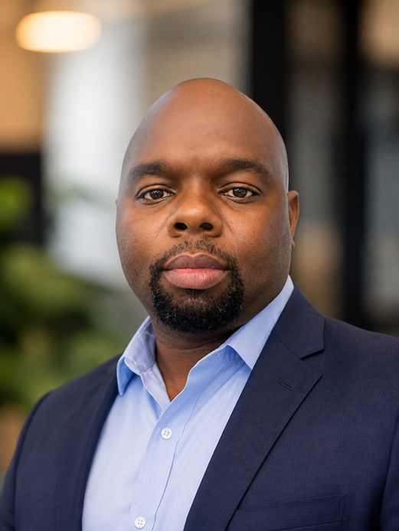 Dr. Kadeghe Goodluck Fue is a Senior Lecturer at Sokoine University of Agriculture in Tanzania, specializing in agricultural robotics, agricultural data science, agricultural informatics, and applied Artificial Intelligence. He earned his Ph.D. from the University of Georgia and leads the Electronics and Precision Agriculture Lab, where he develops autonomous rovers, AI systems, Data Science solutions, IoT sensors, and computer vision systems. He also directs institutional digitalization initiatives and champions open-source digital public infrastructure for African smallholders.

